📘 User Manual: Aiam Agentic Job Search Engine
Autonomous Multi-Agent AI Career Copilot & Job Application Engine

1. Architecture & Pipeline Overview
The Aiam Agentic Job Search Engine orchestrates 5 specialized AI agents working sequentially alongside an automated Swarm Orchestrator:
- Agent 1: Ready for Resume: Candidate Intake, PDF/TXT file drag & drop + text merging, and skill extraction.
- Agent 2: Ready for Preferences: Target Roles, Work Modes (Remote/Hybrid/Onsite), Salary, City & Country configuration.
- Agent 3: Ready for Search: Live SerpAPI Google Jobs Crawler with City, Country badges and fallback database.
- Agent 4: Ready for Fitment: 100-Point Weighted Match Engine (Skills 0-60, Seniority 0-20, Preferences 0-20).
- Agent 5: Executive Dashboard: Macro Analytics, Skillset Alignment Matrix, Strategy Pathways & Tailored Cover Letters.
- Agent 6: Swarm Orchestrator: 1-Click Full Pipeline Automation with live terminal logging.
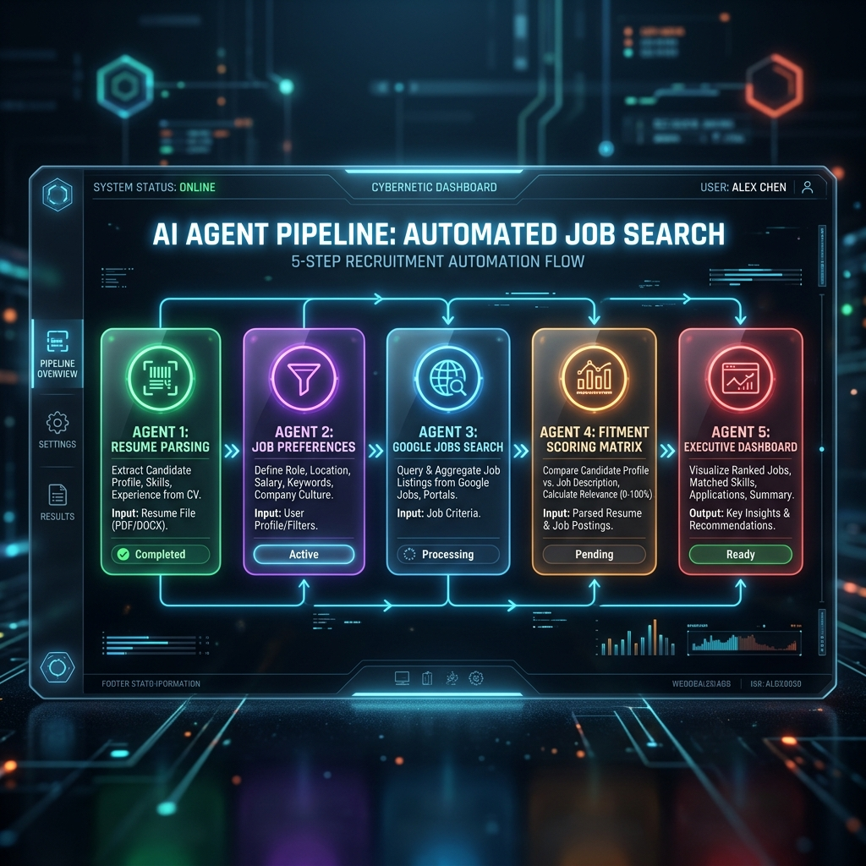
Figure 1: 5-Step AI Agent Pipeline & Swarm Architecture

2. Quick Start Guide
Step 1: Start Native Node Server
Open terminal in the project folder and run: node server.js
Step 2: Launch Application Interface
Navigate to http://localhost:8080 in any web browser (Chrome, Edge, Firefox).

3. Detailed Step-by-Step Operating Instructions

Step 1: Candidate Intake (Agent 1)
Drag & drop resume files (.txt, .pdf, .docx) into the dropzone or paste resume text. Click 'Perform Agent Task'. Agent 1 combines both sources into a unified profile extracting Candidate Name, Title, Experience Years, Qualification, and Skill Priorities.

Step 2: Set Job Preferences (Agent 2)
Specify target roles (e.g., 'Senior Java Developer, Cloud Architect'), work modes (Remote, Hybrid, Onsite), employment types (Full Time, Contract), target City, and Country. Click 'Perform Agent Task'.

Step 3: Google Jobs Search (Agent 3)
Click 'Perform Agent Task'. Agent 3 merges Agent 1 skills with Agent 2 location preferences to query SerpAPI Google Jobs engine, displaying job cards with explicit 📍 City, Country metadata.

Step 4: Fitment Assessment Matrix (Agent 4)
Select target jobs and run fitment scoring. The 100-point algorithm calculates Skills Match (0-60), Seniority Alignment (0-20), and Preferences Alignment (0-20).

Step 5: Executive Dashboard & AI Cover Letters (Agent 5)
View macro stats (Total Jobs Evaluated, Average Fit Score, High Match Count), Skillset Alignment Matrix (Spider Chart), and generate 1-click tailored cover letters.
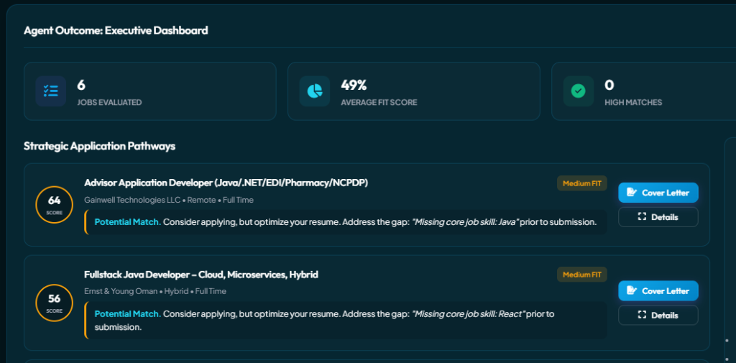
Figure 2: Agent 4 Fitment Evaluation Scorecard UI

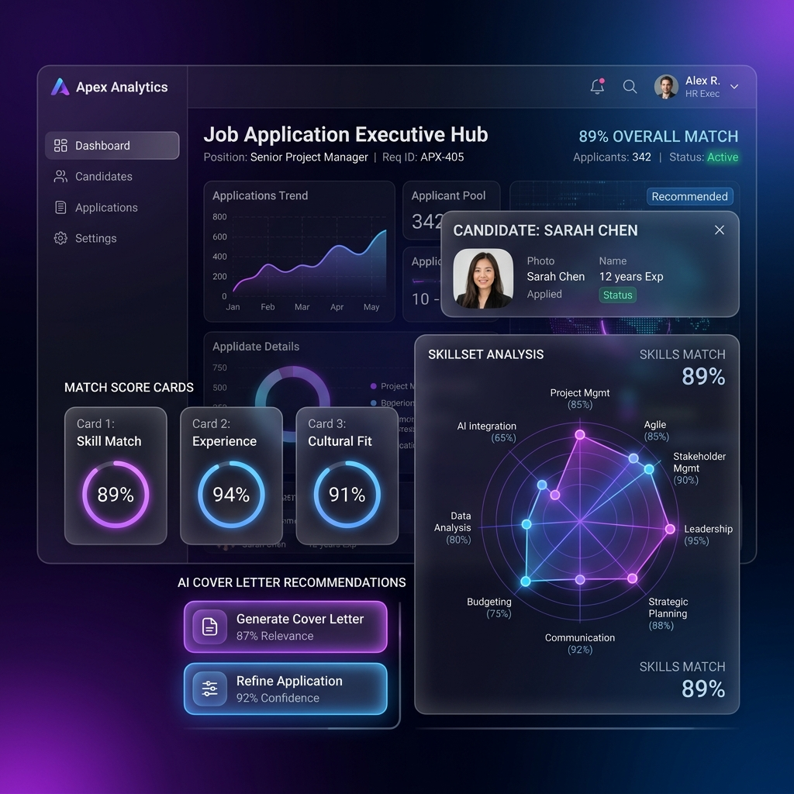
Figure 3: Agent 5 Executive Dashboard & Analytics Matrix

4. UI Theme Customization (11 Dynamic Color Themes)
Select any of the 11 dynamic color themes from the sidebar widget. Theme choices persist automatically in browser storage:
Theme Name | Style & Aesthetic Description
Cyber Violet (Default) | Obsidian dark mode with glowing neon violet & indigo
Emerald Matrix | Cyber emerald green & tech mint accents
Midnight Sapphire | Deep navy blue & electric azure glow
Solar Flare | Solar orange & amber energy highlights
Neon Cyberpunk | Hot pink & electric cyan dual glow
Pearl Glass | Ultra-sleek modern light mode with soft glassmorphic shadows
Crimson Obsidian | Dark velvet crimson & ruby fire accents
Velvet Nebula | Deep violet & lavender glow
Arctic Frost | Frosted cyan & ice blue accents
OLED Pure Black | High-contrast monochrome pitch black
Titanium Bronze | Industrial metallic titanium & bronze highlights

